과제 1

**import** java.util.Scanner;

**public** **class** Pa {

**public** **static** **void** main(String[] args) {

// **TODO** Auto-generated method stub

**int** n;

Scanner sc = **new** Scanner(System.*in*);

System.*out*.println("팩토리얼을실행할정수를입력하세요 :");

n = sc.nextInt();

System.*out*.println(n+"! ="+ *factorial*(n));

}

**public** **static** **int** factorial(**int** n) {

**if** (n <=1){ **return** 1;

}**else**

**return** (n \**factorial*(n -1));

}

}

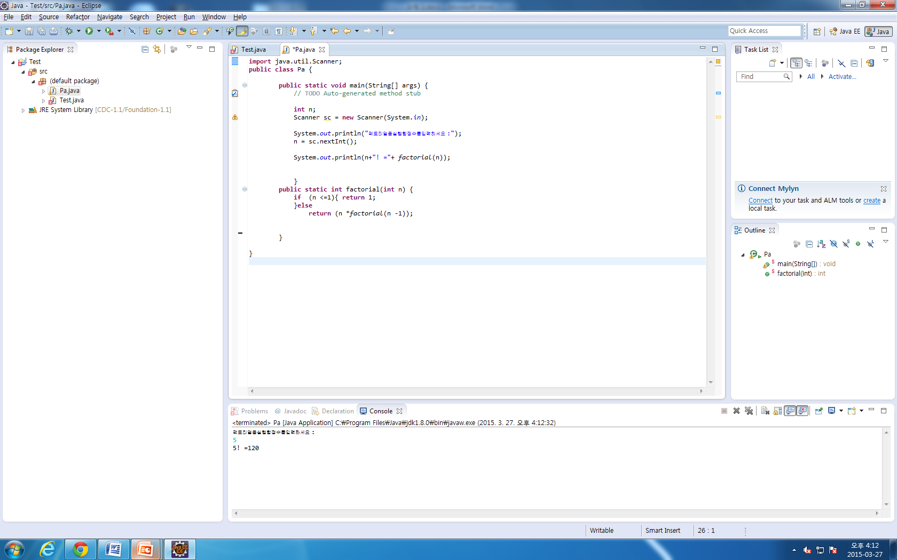

과제 2

**import** java.util.Scanner;

**public** **class** Test {

**public** **static** **void** main(String[] args) {

// **TODO** Auto-generated method stub

**int** key;

Scanner input = **new** Scanner(System.*in*);

**int**[] arr = {1, 2, 3, 4, 6, 8, 9, 11, 13, 16, 19, 20};

System.*out*.println("찾으려는숫자를입력하세요(0~20사이의정수) :");

key = input.nextInt();

*binsearch*(arr, key, 0, arr.length);

}

**static** **void** binsearch(**int** arr[], **int** key, **int** left, **int** right) {

**int** mid = (left + right)/2;

**if**(left<=right){

**if**(key == arr[mid]){

System.*out*.println("찾으려는숫자는 ["+ mid +"]번째인덱스에있습니다.");

}**else** **if**(key < arr[mid]) {

*binsearch*(arr, key, left, mid-1);

}**else** **if**(key > arr[mid]) {

*binsearch*(arr, key, mid+1, right);

}

}**else**

System.*out*.println(key+"값이 존재하지 않음");

}

}

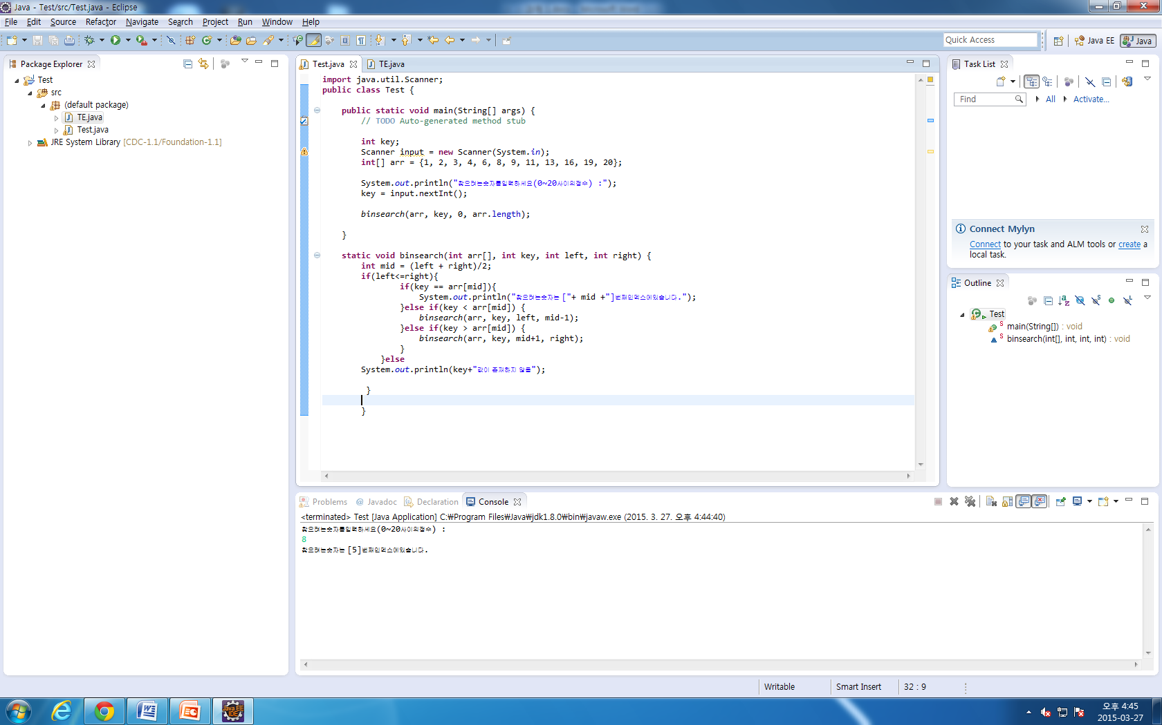

과제 3

**import** java.util.Scanner;

**public** **class** TE {

**public** **static** **void** main(String[] args) {

**int** n;

Scanner sc = **new** Scanner(System.*in*);

System.*out*.println("피보나치 수열을 진행할 정수를 입력하세요 :");

n = sc.nextInt();

**for**(**int** i = 0; i<n; i++){

System.*out*.print(*fib*(i)+" ");

}

}

**public** **static** **int** fib(**int** n){

**if** (n<=0){

**return** 0;

}**else** **if**(n==1) {

**return** 1;

}

**else** **return** (*fib*(n - 1) + *fib*(n -2));

}

}

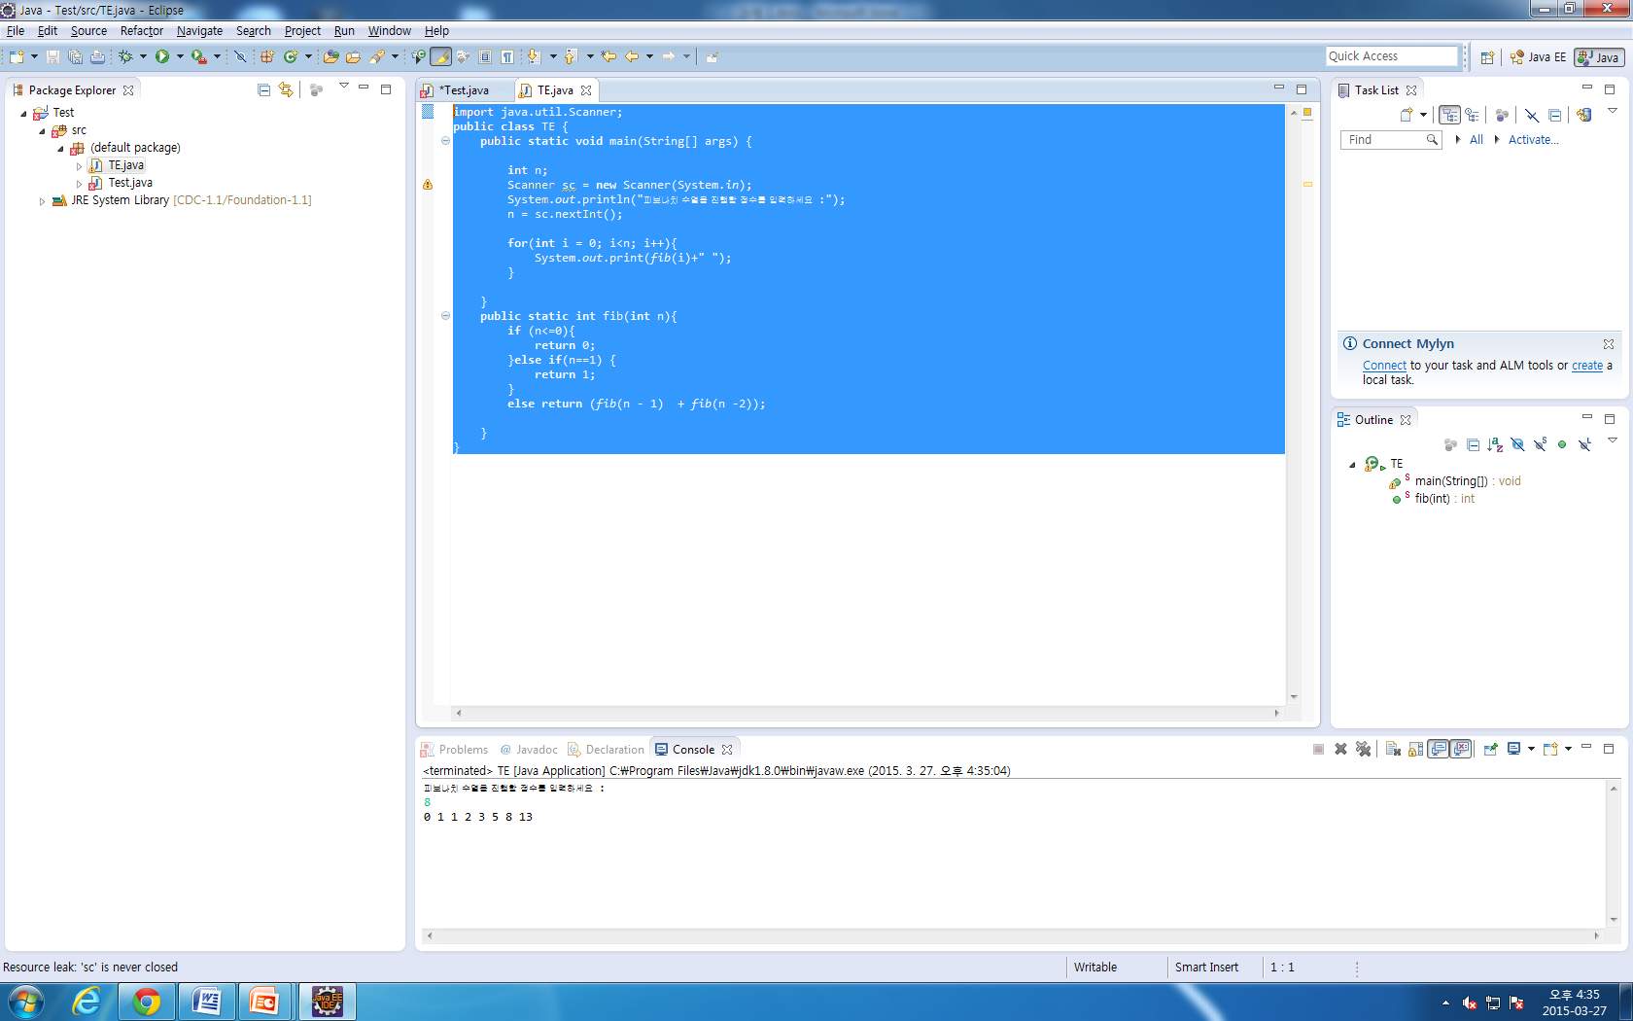

과제 4

**import** java.util.Scanner;

**public** **class** TE {

**public** **static** **void** main(String[] args) {

Scanner sc = **new** Scanner(System.*in*);

System.*out*.println("이진수로 변환할 십진수를 입력하세요(양수) :");

**int** n = sc.nextInt();

*writeBinary*(n);

}

**public** **static** **void** writeBinary(**int** n){

**if**(n<=1){

System.*out*.print("1");

**return**;

}**else**

*writeBinary*(n/2);

System.*out*.print(n%2);

}

}

